"I always wanted to be in a historical event, but nothing like this. This is a bad historical event." — Naima John, age 9

What Living Through a Pandemic Is Like for Kids

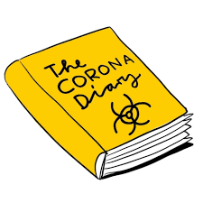
The children of writers and editors describe how they’re feeling about all of this.

Dear pupils from class 7c, 8b and 9c,
These headlines are taken from diaries/texts kids and teenagers have written about life in corona times. Because I think it doesn’t make much sense to torture you with grammar worksheets and you are part of a really historic event, I would like you to start your Corona Diary.
Your job is to write at least 4-5 lines a day on your computer and start with it on Wednesday March 25th. When school starts again (whenever this is) I would like you to print out your diary and hand it in. Be sure that only I will read this diary if you don’t want it to be seen by others. I would appreciate if you continue the diary in the holidays, but this is a two week project so you can stop at April 8^{th.}
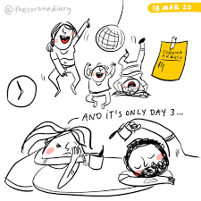
In your diary you can write about
- things you have done at that special day (reading, watching TV, jogging…)
- things you have eaten
- feelings (good ones / bad ones)
- things/people you miss
- things that piss you off or make you happy…
- ???
stay healthy and stay home! – All the best, Mr D
Example:
Corona Diary of Mr D
March 22nd Sunday
It’s been a week that school has been closed and things still feel very unreal. I was - like most people- happy and shocked at the same time. My complete family has been at home since day one of the school and kindergarten closure and we have very much time together. Most times this is pretty cool, but sometimes we go on each other’s nerves very quickly.
Today has been a very beautiful day. We went jogging as a family, so my kids were cycling and me and my wife were jogging and in the afternoon we had waffles. Yummy! I phoned my best friend, read stories to the kids and watched a film in the evening….

March 23nd Monday
This is crazy. Now when Fynn and Leni could sleep longer, they are awake before 7 o’clock. They always shout and complain when they have to get up at that time on normal Mondays. After breakfast we watched “Sendung mit der Maus” and played some Lego. The best thing of the day was our walk in the forest. The weather was brilliant.
I really miss to see my best friends and maybe I need some time for myself - alone… For dinner we had pumpkin soup and bread. It was okayish. Now I have to finish some work for school and that’s the end of day two.

Liebe Eltern,
ein kurzer Hinweis für Sie. Ihre Kinder sollen ein „Corona-Tagebuch“ auf English führen. Dieses Tagebuch ist für 2 Wochen zu führen und jeden Tag sollten ihre Kinder circa 5 Zeilen zu Papier bzw. bitte in den Rechner bringen.
Bleiben Sie alle zu Hause und vor allem gesund!

